Whistle Blowing Policy

Authors | Kate Lunn
Policy Lead | Kate Lunn
Date Ratified by management team | July 2018
Status | Ratified
Last Review Date | July 2018
Policy Number | CVSE doc 50

Introduction

Calder Valley Steiner School (CVSE) is committed to maintaining a culture of openness, accountability and integrity. We seek to ensure that employees feel secure in raising concerns about any activity which may harm individuals or undermine the status of the school.

The school has adopted the Calderdale Council Guidelines and reporting template for Whistle Blowing.

This policy gives clear guidance to those who may need to raise concerns.

Roles and responsibilities
All Staff are responsible and accountable for their action/non-action.

Information for all staff

As a person working for Calder Valley Steiner school, you may be the first to realise that there could be something seriously wrong within the school. However, you may feel that speaking up would be disloyal to your colleagues, you may also fear reprisal. In these circumstances it may be easier to ignore the concern rather than report what may just be a suspicion of malpractice.

We are committed to the highest possible standards of openness, integrity and accountability. We expect employees, and others that we deal with, who have serious concerns about any aspect of our work to come forward and voice those concerns.

The purpose of this Policy and the accompanying Whistle-blowing Procedure is to reassure you and to make it clear that you can raise your concerns in confidence. We would encourage you to raise serious concerns, in the first instance within the School (in line with Calderdale Council Whistle blowing Policy). Please do not ignore the problem or ‘blow the whistle’ outside, we would rather that you raised the matter as soon as you note a concern. Please do not wait for proof.

You should raise appropriate concerns with the Designated Safeguarding Lead, Kate Lunn.
Or consequently if the matter concerns them, the Chair of trustees. The Chair of Trustees is Richard Bunzl and his contact details can be found on the school web page.

The Policy and Procedure applies to all staff within the school.

The Policy has been prepared in response to the Public Interest Disclosure Act 1998 in accordance with Government guidance on the issue.

We recognise employees may wish to seek advice and be represented by their trade union representative when raising a concern under the Policy and acknowledge and endorse the role trade union representatives may play in this area.
Trade union representatives acting in accordance with the Policy and Procedure will not suffer detriment in their employment with us.

Aims of the policy

This policy aims to:

- Encourage you to feel confident in raising serious concerns
- Ensure all staff realise they are all accountable for their actions/non-action in reporting serious concerns
- Provide avenues for you to raise those concerns and receive feedback on any action taken subsequently
- Ensure that you receive a response to your concerns
- Reassure you that you will be protected from possible reprisals

There are existing procedures in place within the school, to enable employees to report grievances relating to their employment. The Whistle blowing Policy is intended to cover concerns that fall outside of the scope of other procedures. This policy therefore includes your concerns about:

- Conduct which is an offence or a breach of law
- Harassment of others*
- Sexual, racial or disability discrimination against others*
- Disclosures related to miscarriages of justice
- Health and safety risks, including risks to the public as well as other employees
- Damage to the environment
- The unauthorised use of funds
- Possible fraud and corruption
- Sexual or physical abuse of staff or pupils
- Child abuse or safeguarding issues
- Other unethical or improper conduct (not otherwise included in this list)
- Concealing information about any of these matters

*Complaints relating to harassment of or discrimination against an individual will be dealt with under the specific procedures relating to those matters.

Further information and school principles

We are committed to good practice and high standards and want to be supportive of employees and others who work for us.

We recognise that the decision to report a concern can be a difficult one to make. If you raise your concern based on reasonable belief and in good faith, you have nothing to fear because you will be doing your duty to your employer and the public and The Public Interest Disclosure Act 1998 will protect you from dismissal or other detriment. If your concern is not confirmed by the investigation, no action will be taken against you. If, however, you make an allegation frivolously, maliciously or for personal gain, disciplinary action may be taken against you.

CVSE employees must acknowledge the individual responsibilities to bring matters of concern to the attention of management and/or outside agencies.
Whilst this is difficult it is important where the welfare and safety of children may be at risk
You may be the first to recognise something is wrong but may not feel able to discuss your concerns with your colleagues. This may be out of loyalty or you may fear harassment or victimisation.
These feelings however natural, must never result in a child or young person continuing to be at risk.
Remember, it is often the most vulnerable children or young people who are targeted.
These children need us all to be vigilant to safeguard their welfare
The school will always listen and investigate with your safety in mind. We will be discreet and always consider the impact to you.

Thought - Don’t think “what if I am wrong?” It is essential to think “what if I am right?”

Reasons to Whistle Blow on safeguarding issues
- you have a concern about unacceptable practice or behaviour
- you notice a situation that causes unease and you feel is wrong
- to prevent an issue escalating
- to protect others and reduce risk to yourself
- to prevent yourself becoming implicated

Think about what is stopping you from whistle blowing
- starting a chain of events which spirals
- disrupting the working day
- fear of getting it wrong
- fear of repercussions or damaging reputation and careers
- fear of not being believed
None of the above should be an issue, remember all will be done discreetly and with as little interruption as possible.

Confidentiality

All concerns will be treated in confidence and every effort will be made not to reveal your identity if you so wish. If we are not able to resolve your concern without revealing your identity (e.g. because your evidence may be needed in Court), we will discuss this with you.

Anonymous allegations

This policy encourages you to put your name to your allegation whenever possible.

Concerns expressed anonymously are much less powerful but may be considered by us taking into account:
- The seriousness of the issues raised
- The credibility of the concern
- The likelihood of confirming the allegation from attributable sources.

The Whistle blowing Procedure
This procedure is represented in a flow chart (Appendix 2)

Raising a concern

1.1 As a first step, you should normally raise concerns with the school manager. This depends, however, on the seriousness and sensitivity of the issues involved and who is suspected of the malpractice.

1.2 If you are unsure whether or how to raise a concern you can contact the independent voluntary organisation Public Concern at Work on 020 7404 6609, for guidance.

1.3 Concerns may be raised orally or in writing on the Whistle blowing Form attached to this Procedure (Appendix 1) and which you can obtain from the school manager.

1.4 The lead safeguarding person/school manager, as the Officer responsible for this Policy, will be informed of all concerns raised under the Policy (unless, of course, they are against these staff members).

1.5 If you believe that senior management is involved, or if you are not happy with response to your concerns, you should approach the:
- Chair of Trustees, Richard Bunzl
- Ofsted (number is on this policy)
- Trustee responsible for safeguarding, Rory O’Niell

  - The earlier you express the concern the easier it is to take action.

  - Although you are not expected to provide proof for your concern, you will need to demonstrate to the person contacted that there are reasonable grounds for your concern.

  - You may wish to consider discussing your concern with a colleague first and you may find it easier to raise the matter if there are two (or more) of you who have had the same experience or concerns.

  - You may invite your trade union, professional association representative or a friend to be present during any meetings or interviews in connection with the concerns you have raised. Any meetings that need to be arranged with you can be held off-site if you wish.

2. HOW WE WILL RESPOND

2.1 Whoever you raise your concerns with will appoint a person unassociated with the matter to look into it. You will be informed who this is. Confidentiality will be maintained.

2.2 In order to protect individuals and those accused of misdeeds or possible malpractice, this person will carry out initial enquiries in order to decide whether an investigation is appropriate and, if so, what form it should take. The overriding principle which we have in mind is the public interest and child welfare. Concerns or allegations which fall within the scope of specific procedures (for example, child protection, and harassment or discrimination issues) will normally be referred for consideration under those procedures.

2.3 Following these initial enquiries, we will respond to your concerns as appropriate. Your concern may: -

- be investigated by management, internal audit, or through the disciplinary process
- be referred to the police
- be referred to an external auditor
- form the subject of an independent inquiry.

  - Some concerns may be resolved by action agreed with you without the need for formal investigation. If urgent action is required this will be taken before any investigation is conducted.

  - Within seven working days of a concern being raised, the person appointed to look into it will contact you (in a way which does not arouse suspicions in your workplace):

- acknowledging that the concern has been received;
- indicating how we propose to deal with the matter
- giving an estimate of how long it will take to provide a final response
- telling you whether any initial enquiries have been made
- supplying you with information on staff support mechanisms
- advising you of your entitlement to seek advice and representation from your trade union representative
- telling you whether further investigations will take place and if not, why not
- to agree with you how to proceed if you have chosen to remain anonymous.

  - We will do what we can to minimise any difficulties which you may experience as a result of raising a concern. For instance, if you are required to give evidence in criminal or disciplinary proceedings we will arrange for you to receive advice about the procedure and other appropriate support.

  - We accept that you need to be assured that the matter has been properly addressed. Subject to legal constraints and any confidentiality or other issues, we will inform you of the outcome of any investigation.

Summary
This policy aims to:
- Encourage you to feel confident in raising serious concerns and to question and _{act} upon concerns.
- Provide avenues for you to raise those concerns and receive feedback on any action taken.
- Ensure that you receive a response to your concerns and that you are aware of _{how} to pursue them if you are not satisfied.
- Reassure you that you will be protected from possible reprisals or victimisation if you have a reasonable belief that you have raised any concern in good faith.

Useful numbers

E-mail to: whistleblowing@calderdale.gov.uk

Post to: Whistleblowing c/o Head of Democratic and Partnership Services Calderdale Council Northgate House Halifax HX1 1UN

Telephone: 01422 39356

Ofsted 03001231231

NSPCC whistleblowing hotline 08000280285

Or in writing to: Ofsted, Piccadilly Gate, Store Street, Manchester, M1 2WD

Monitoring and evaluation
The School manager will ensure that this policy is disseminated to all Staff.
The Designated trustee for Safeguarding will do occasional spot checks, to ensure that Staff are aware of this Policy and the procedures within it.

Prepared with reference to the DFE publication “keeping children safe in Education” July 2015

Appendix 1.

Strictly Confidential

Report Form
Name of Employee making complaint
(You are encouraged to insert your name, but may choose not to do so - the recipient of the form will make every effort to maintain confidentiality)
Person(s) reported
Concerns reported (Give full details of the background to the concern; names, dates and places; and the reasons why you are concerned - ATTACH A SEPARATE SHEET IF NECESSARY)

Date
Signed (If employees name appears above)

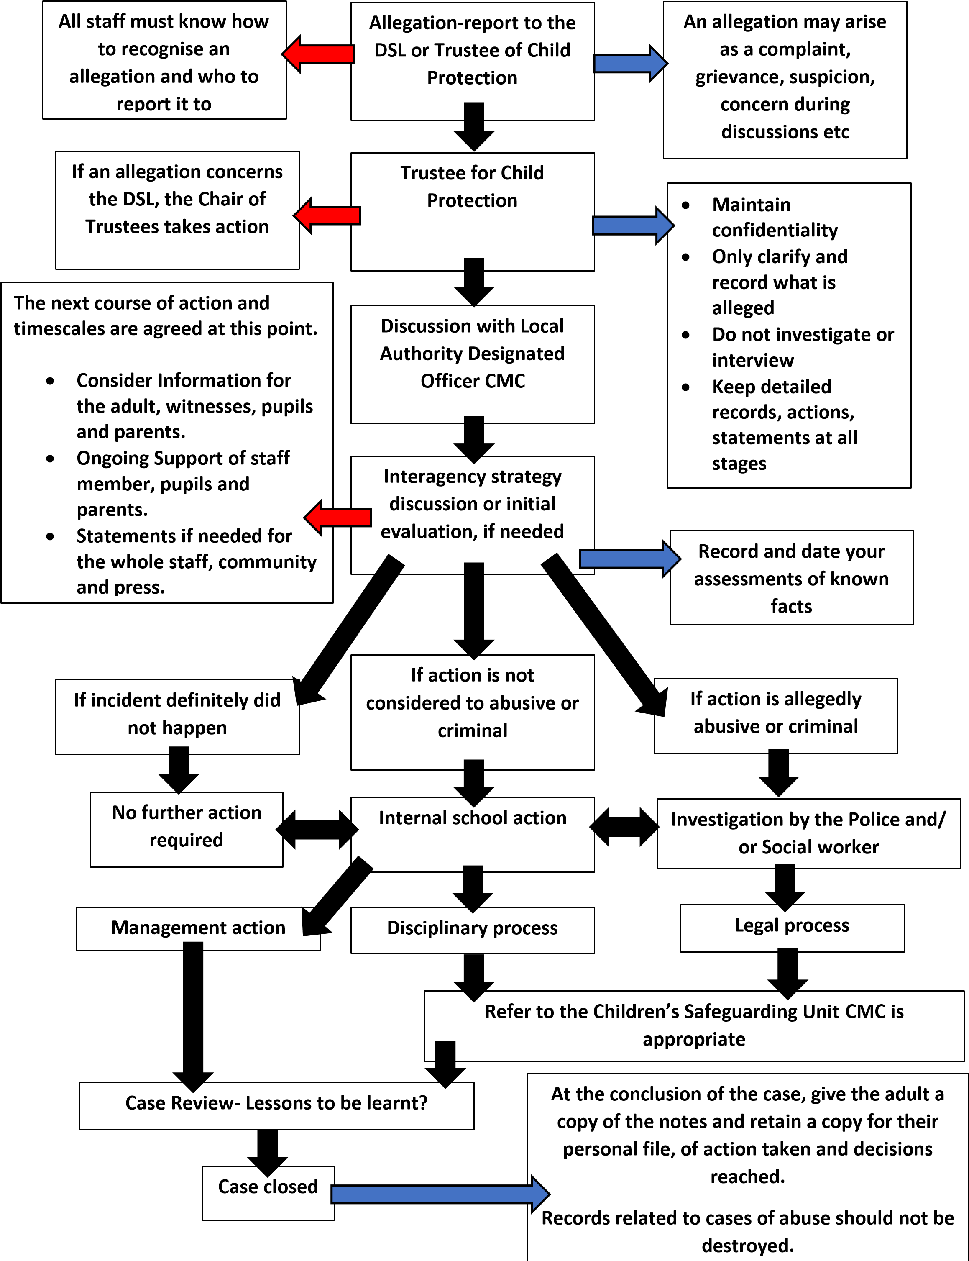
Appendix 2: CVSS Managing a Whistleblowing Allegation against a member of staff

Reflections
N.B- After a case is closed and no further action is taken we must consider:
- Why a young person has made an allegation?
- Do we need to make a referral for an assessment of need?
- How does the establishment move on from here?
- Do policies and procedures need updating?
- Do staff, pupils, parents need more guidance and support either now or in the future?

